Point on a Line Segment

Definition
# Source: AI Source: Provided by: [Data Path: Persons Table -> ID Column: 1, Name_En Column: Motasem Essam] -> From: [ChatGPT] on [7/25/2026]
Point on a Line Segment is a type of Point Containment in which a point lies on the finite portion of a line between two endpoints.
For a line segment with endpoints A and B, a point P is contained in the segment when:
$$\boxed{P∈\overset{‾}{AB}}$$
This means that P lies between A and B or coincides with one of the endpoints.
Unlike a line, a line segment has a finite extent.
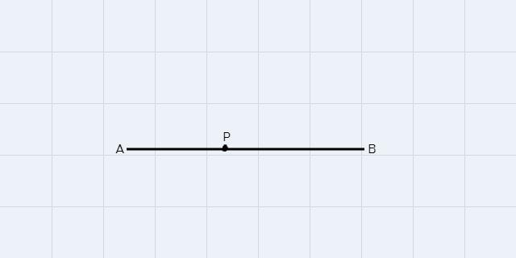
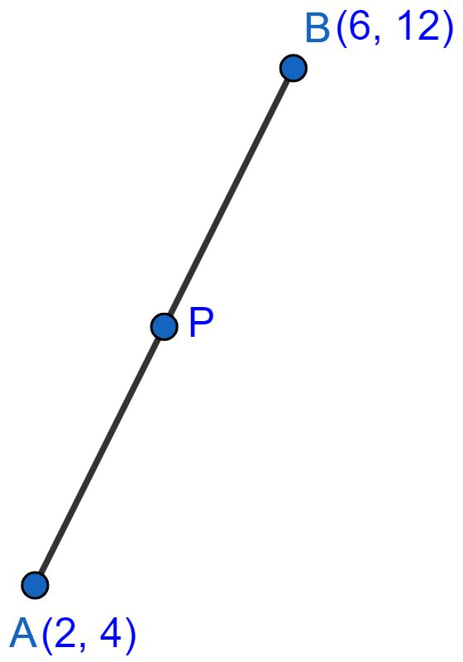
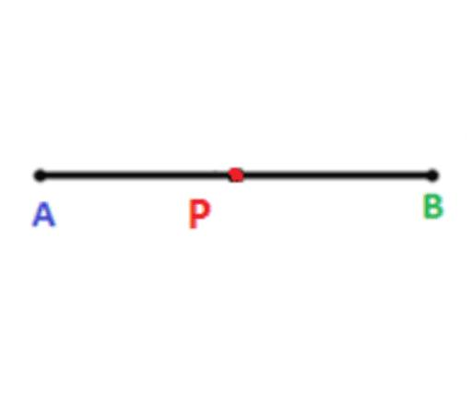

Purpose
# Source: AI Source: Provided by: [Data Path: Persons Table -> ID Column: 1, Name_En Column: Motasem Essam] -> From: [ChatGPT] on [7/25/2026]
Point-on-segment containment is used to:
- Determine whether a point belongs to a particular line segment.
- Determine whether a point lies between two endpoints.
- Establish collinearity and betweenness relationships.
- Divide a segment into smaller segments.
- Solve coordinate-geometry problems.
- Analyze intersections between line segments.
- Verify geometric constructions.

Fundamental Concept
# Source: AI Source: Provided by: [Data Path: Persons Table -> ID Column: 1, Name_En Column: Motasem Essam] -> From: [ChatGPT] on [7/25/2026]
A line segment is the set of points between two endpoints, including the endpoints.
For segment:
$$\overset{‾}{AB}$$
we can write:
$$\overset{‾}{AB}=\left\{P∣P\text{ lies between }A\text{ and }B\right\}$$
with the endpoints included.
Therefore:
$$\boxed{P∈\overset{‾}{AB}}$$
means that P is on the segment.
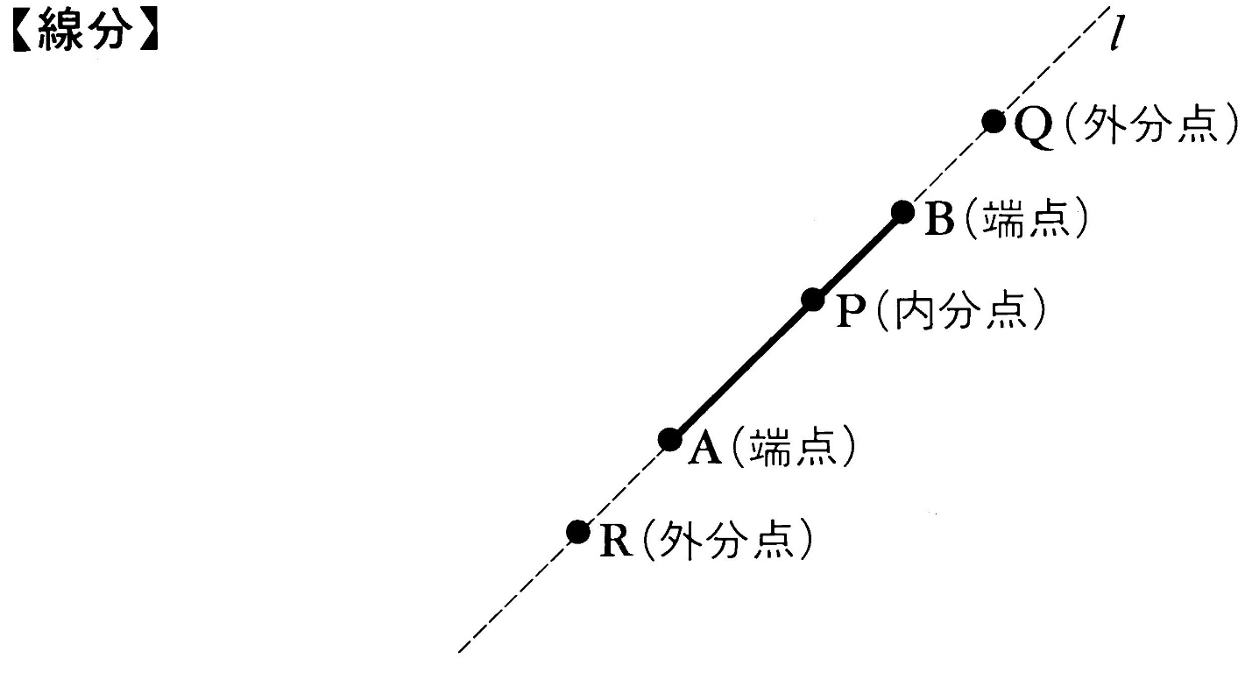
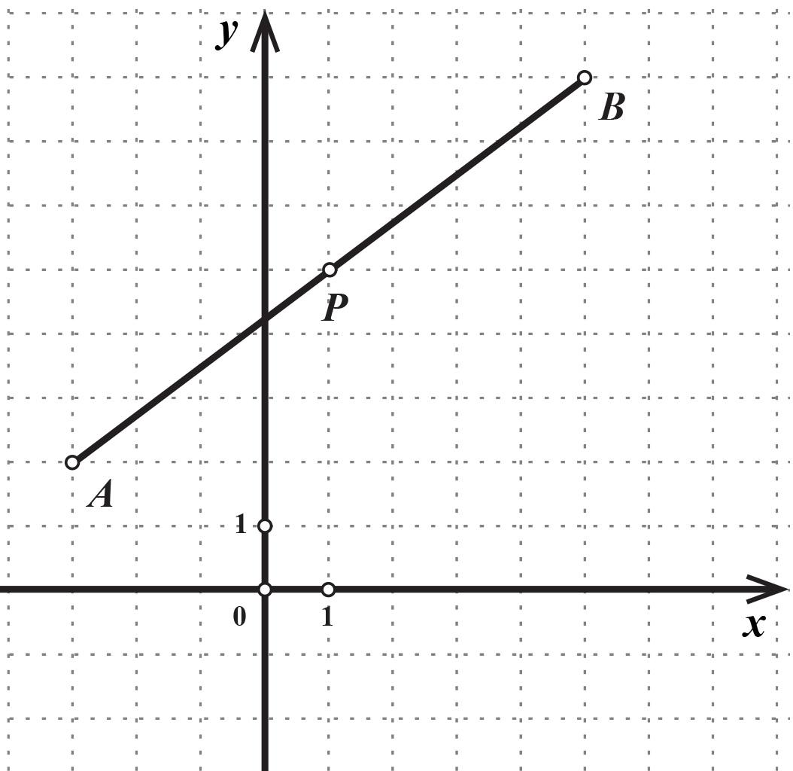

Three Possible Positions of a Point
# Source: AI Source: Provided by: [Data Path: Persons Table -> ID Column: 1, Name_En Column: Motasem Essam] -> From: [ChatGPT] on [7/25/2026]
Given a segment \overline{AB}, a point can have three relevant positions along its supporting line.

1. Inside the Segment
# Source: AI Source: Provided by: [Data Path: Persons Table -> ID Column: 1, Name_En Column: Motasem Essam] -> From: [ChatGPT] on [7/25/2026]
If P lies strictly between A and B:
$$\boxed{P∈int⁡\left(\overset{‾}{AB}\right)}$$
For example:
A ───── P ───── B

2. At an Endpoint
# Source: AI Source: Provided by: [Data Path: Persons Table -> ID Column: 1, Name_En Column: Motasem Essam] -> From: [ChatGPT] on [7/25/2026]
The endpoints themselves are contained in the segment:
$$\boxed{A∈\overset{‾}{AB}}$$
and:
$$\boxed{B∈\overset{‾}{AB}}$$
For example:
P=A ───────── B
or:
A ───────── P=B

3. Outside the Segment
# Source: AI Source: Provided by: [Data Path: Persons Table -> ID Column: 1, Name_En Column: Motasem Essam] -> From: [ChatGPT] on [7/25/2026]
A point can lie on the supporting line but outside the finite segment:
P ─── A ───────── B
In this case:
$$\boxed{P∉\overset{‾}{AB}}$$
even though:
$$P∈\overset{↔}{AB}$$
This is one of the most important distinctions between a line and a line segment.

Mathematical Representation
# Source: AI Source: Provided by: [Data Path: Persons Table -> ID Column: 1, Name_En Column: Motasem Essam] -> From: [ChatGPT] on [7/25/2026]
The primary notation is:
$$\boxed{P∈\overset{‾}{AB}}$$
If the point does not belong to the segment:
$$\boxed{P∉\overset{‾}{AB}}$$
The notation:
$$\overset{‾}{AB}$$
represents the finite segment from A to B.

Point-on-Segment Test in One Dimension
# Source: AI Source: Provided by: [Data Path: Persons Table -> ID Column: 1, Name_En Column: Motasem Essam] -> From: [ChatGPT] on [7/25/2026]
Suppose:
$$A=x_{1}$$
and:
$$B=x_{2}$$
with a point:
$$P=x$$
on the same number line.
The point lies on the segment if:
$$\boxed{min⁡\left(x_{1} , x_{2}\right)≤x≤max⁡\left(x_{1} , x_{2}\right)}$$
For example:
$$A=2, B=8$$
and:
$$P=5$$
Since:
$$2≤5≤8$$
we have:
$$\boxed{P∈\overset{‾}{AB}}$$

Point-on-Segment Test in Two Dimensions
# Source: AI Source: Provided by: [Data Path: Persons Table -> ID Column: 1, Name_En Column: Motasem Essam] -> From: [ChatGPT] on [7/25/2026]
For:
$$A=\left(x_{1} , y_{1}\right) \\ B=\left(x_{2} , y_{2}\right)$$
and:
$$P=\left(x , y\right)$$
two conditions must be satisfied.
Condition 1 – Collinearity
P must lie on the line through A and B.
A determinant test is:
$$\boxed{\left(x-x_{1}\right)\left(y_{2}-y_{1}\right)-\left(y-y_{1}\right)\left(x_{2}-x_{1}\right)=0}$$
Condition 2 – Between the Endpoints
The point must lie within the coordinate bounds:
$$\boxed{min⁡\left(x_{1} , x_{2}\right)≤x≤max⁡\left(x_{1} , x_{2}\right)}$$
and:
$$\boxed{min⁡\left(y_{1} , y_{2}\right)≤y≤max⁡\left(y_{1} , y_{2}\right)}$$
If both conditions hold:
$$\boxed{P∈\overset{‾}{AB}}$$

Example 1 – Point on a Horizontal Segment
# Source: AI Source: Provided by: [Data Path: Persons Table -> ID Column: 1, Name_En Column: Motasem Essam] -> From: [ChatGPT] on [7/25/2026]
Let:
$$A=\left(1 , 2\right) \\ B=\left(7 , 2\right)$$
and:
$$P=\left(4 , 2\right)$$
The three points are collinear because they have the same y-coordinate.
Also:
$$1≤4≤7$$
Therefore:
$$\boxed{P∈\overset{‾}{AB}}$$

Example 2 – Point Outside the Segment
# Source: AI Source: Provided by: [Data Path: Persons Table -> ID Column: 1, Name_En Column: Motasem Essam] -> From: [ChatGPT] on [7/25/2026]
Let:
$$A=\left(1 , 2\right) \\ B=\left(7 , 2\right)$$
and:
$$P=\left(9 , 2\right)$$
The point is on the same supporting line, but:
$$9>7$$
Therefore:
$$\boxed{P∉\overset{‾}{AB}}$$
However:
$$\boxed{P∈\overset{↔}{AB}}$$
So the point is on the line but not on the segment.

Example 3 – Point at an Endpoint
# Source: AI Source: Provided by: [Data Path: Persons Table -> ID Column: 1, Name_En Column: Motasem Essam] -> From: [ChatGPT] on [7/25/2026]
Let:
$$A=\left(2 , 3\right) \\ B=\left(8 , 3\right)$$
and:
$$P=\left(2 , 3\right)$$
Since:
$$P=A$$
the point is an endpoint of the segment.
Therefore:
$$\boxed{P∈\overset{‾}{AB}}$$
Endpoints are included in a standard closed line segment.

Example 4 – Point Not Collinear
# Source: AI Source: Provided by: [Data Path: Persons Table -> ID Column: 1, Name_En Column: Motasem Essam] -> From: [ChatGPT] on [7/25/2026]
Let:
$$A=\left(1 , 1\right) \\ B=\left(5 , 5\right)$$
and:
$$P=\left(3 , 4\right)$$
The line through A and B is:
$$y=x$$
But for P:
$$4≠3$$
Therefore:
$$\boxed{P∉\overset{‾}{AB}}$$
The point is neither on the segment nor on its supporting line.

Distance-Based Test
# Source: AI Source: Provided by: [Data Path: Persons Table -> ID Column: 1, Name_En Column: Motasem Essam] -> From: [ChatGPT] on [7/25/2026]
Another useful method is based on distances.
If P lies between A and B, then:
$$\boxed{AP+PB=AB}$$
This is a particularly useful characterization of point-on-segment containment.
For example, if:
$$AP=3$$
and:
$$PB=5$$
then:
$$AB=3+5=8$$
Therefore, if the actual distance between A and B is 8, P can lie between them.
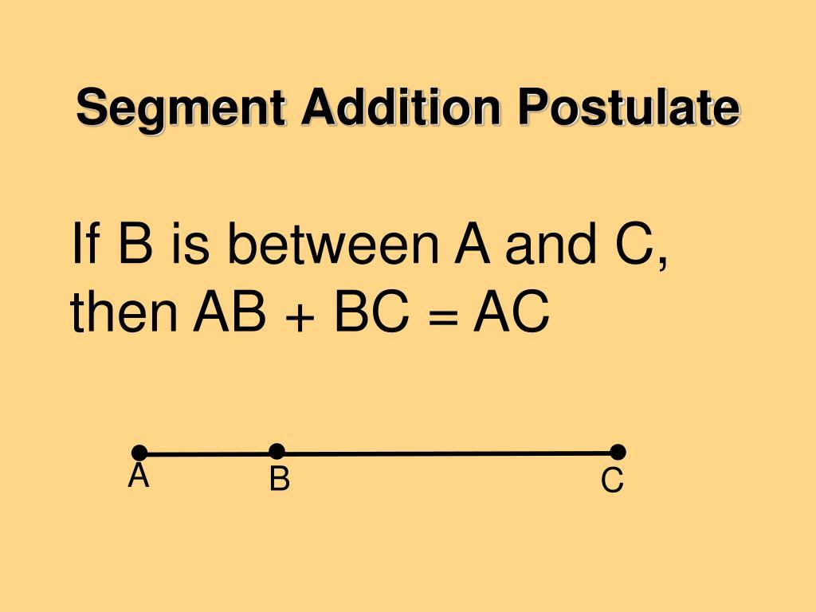
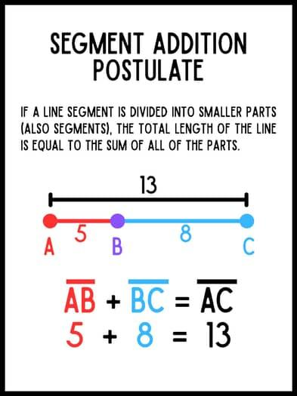
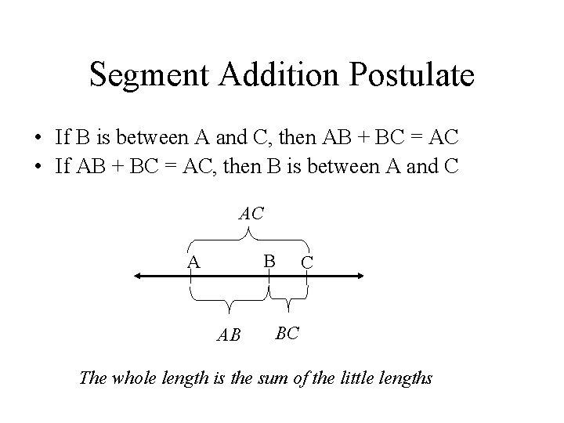
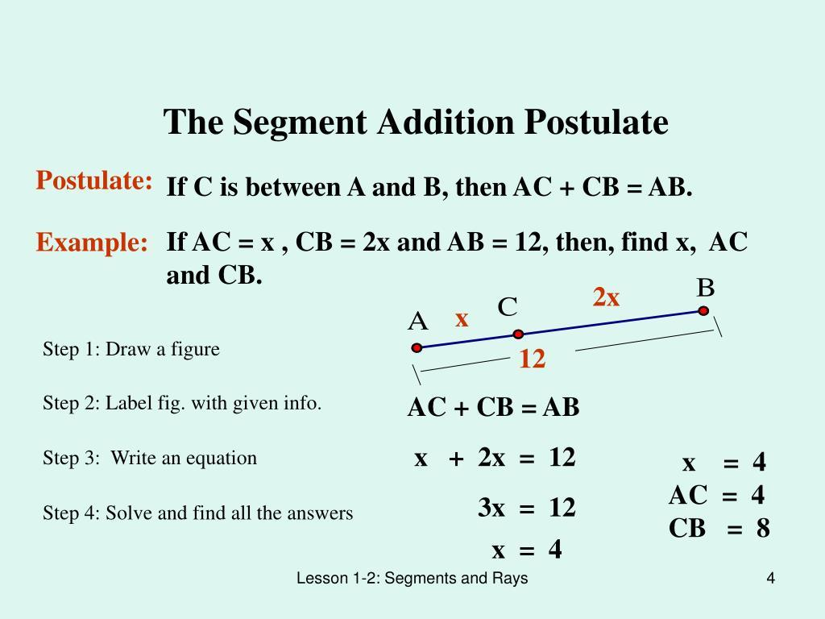

Relationship with the Segment Addition Theorem
# Source: AI Source: Provided by: [Data Path: Persons Table -> ID Column: 1, Name_En Column: Motasem Essam] -> From: [ChatGPT] on [7/25/2026]
If P lies on segment \overline{AB}:
$$\boxed{AP+PB=AB}$$
This is the Segment Addition Theorem.
Thus point-on-segment containment provides the geometric condition that allows the segment to be divided into two smaller segments:
$$\overset{‾}{AB}=\overset{‾}{AP}∪\overset{‾}{PB}$$
with P as their common endpoint.

Vector Representation
# Source: AI Source: Provided by: [Data Path: Persons Table -> ID Column: 1, Name_En Column: Motasem Essam] -> From: [ChatGPT] on [7/25/2026]
A point P lies on segment \overline{AB} if it can be expressed as:
$$\boxed{P=\left(1-t\right)A+tB}$$
where:
$$\boxed{0≤t≤1}$$
This is called an affine combination or linear interpolation between A and B.
Special cases
When:
$$t=0$$
then:
$$P=A$$
When:
$$t=1$$
then:
$$P=B$$
When:
$$0<t<1$$
then P lies strictly between A and B.
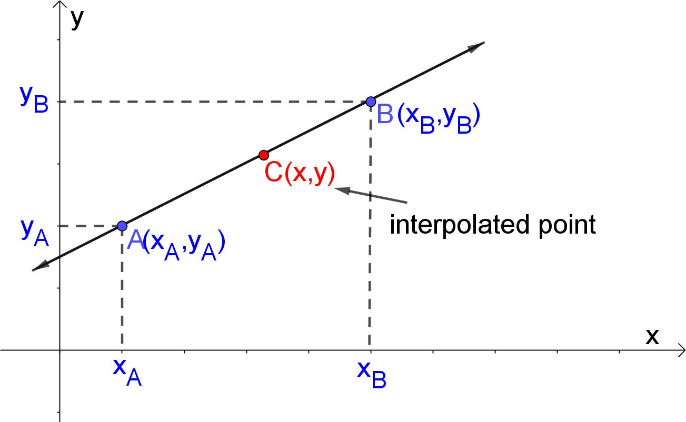
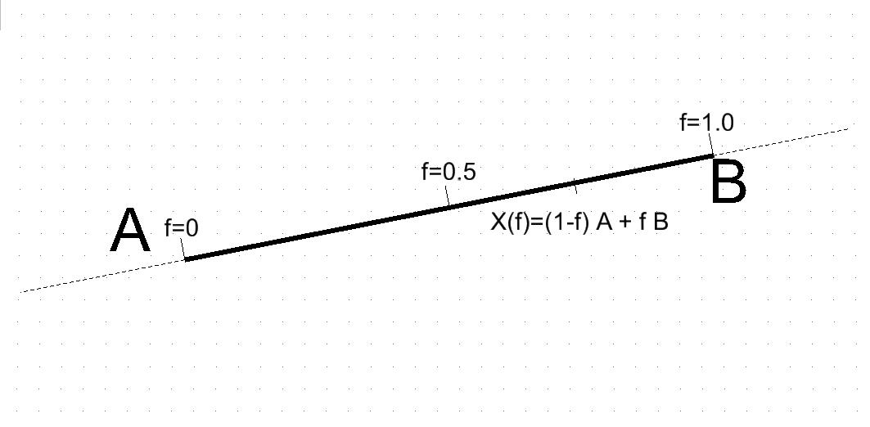
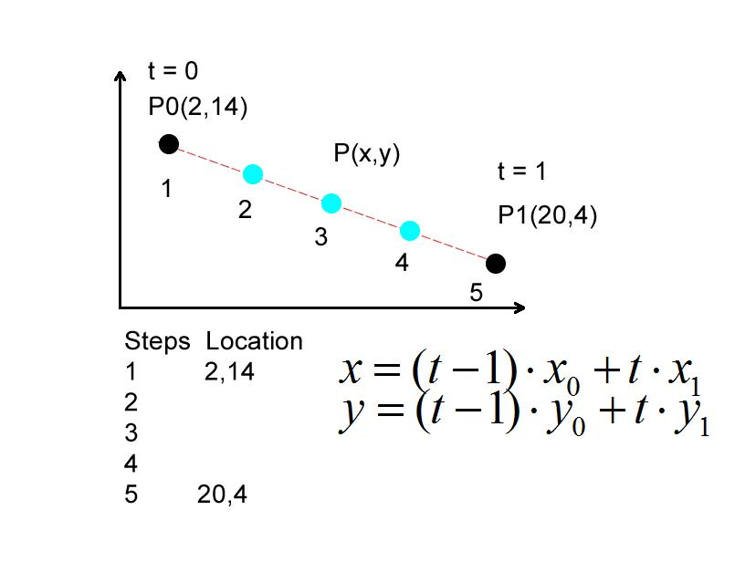
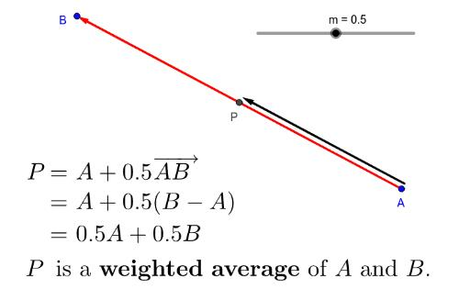
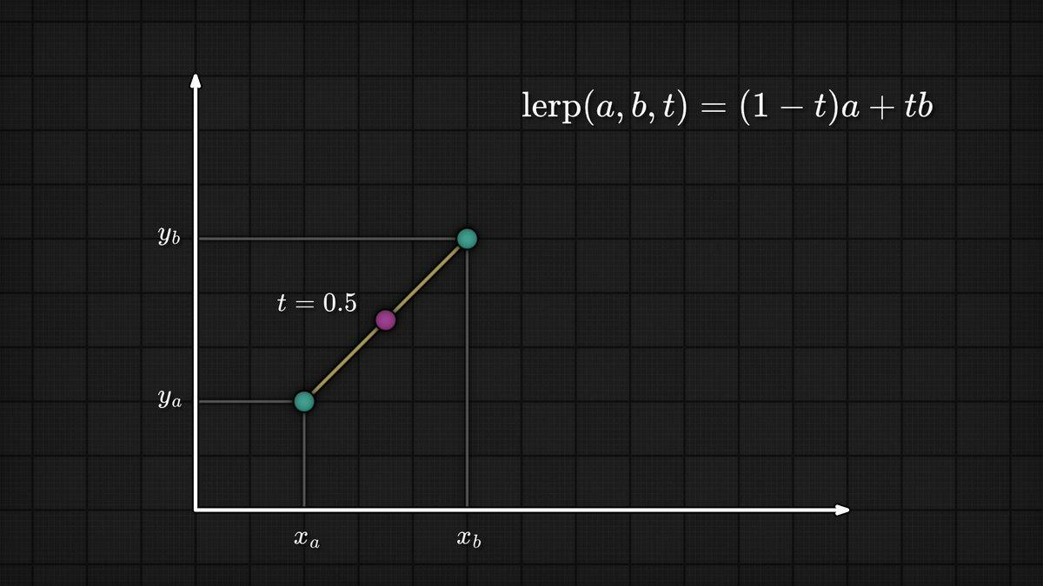

Point on Segment in Three-Dimensional Space
# Source: AI Source: Provided by: [Data Path: Persons Table -> ID Column: 1, Name_En Column: Motasem Essam] -> From: [ChatGPT] on [7/25/2026]
The same principle applies in \mathbb{R}^3.
If:
$$A=\left(x_{1} , y_{1} , z_{1}\right)$$
and:
$$B=\left(x_{2} , y_{2} , z_{2}\right)$$
then a point on the segment can be written as:
$$\boxed{P=\left(1-t\right)A+tB, 0≤t≤1}$$
or component-wise:
$$P=\left(\left(1-t\right) , x_{1} , +tx_{2} \left(1-t\right)y_{1}+ty_{2} \left(1-t\right)z_{1}+tz_{2}\right)$$
This describes every point on the 3D segment.

Point on Segment vs Point on Line
# Source: AI Source: Provided by: [Data Path: Persons Table -> ID Column: 1, Name_En Column: Motasem Essam] -> From: [ChatGPT] on [7/25/2026]
This is one of the most important distinctions.
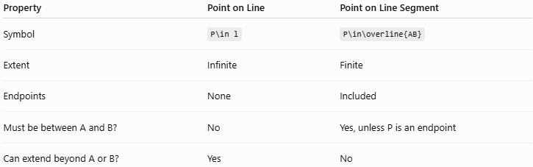
Property | Point on Line | Point on Line Segment
Symbol | P\in l | P\in\overline{AB}
Extent | Infinite | Finite
Endpoints | None | Included
Must be between A and B? | No | Yes, unless P is an endpoint
Can extend beyond A or B? | Yes | No
For example:
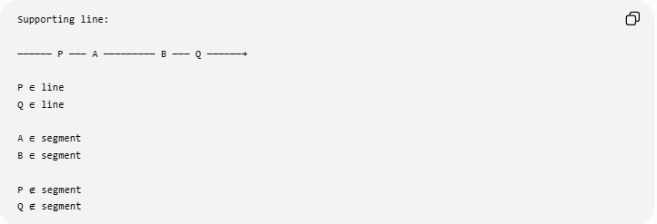
Supporting line:

────── P ─── A ───────── B ─── Q ──────→

P ∈ line
Q ∈ line

A ∈ segment
B ∈ segment

P ∉ segment
Q ∉ segment

Point on Segment vs Point on Ray
# Source: AI Source: Provided by: [Data Path: Persons Table -> ID Column: 1, Name_En Column: Motasem Essam] -> From: [ChatGPT] on [7/25/2026]
A ray has one endpoint and extends infinitely in one direction.
A segment has two endpoints and finite length.
For:
$$\vec{AB}$$
a point beyond B may still belong to the ray.
For:
$$\overset{‾}{AB}$$
that same point does not belong to the segment.

Point on Segment vs Point Inside a Region
# Source: AI Source: Provided by: [Data Path: Persons Table -> ID Column: 1, Name_En Column: Motasem Essam] -> From: [ChatGPT] on [7/25/2026]
These are also different concepts.
Point on a segment
$$P∈\overset{‾}{AB}$$
The point lies on a one-dimensional geometric object.
Point inside a region
$$P∈R$$
The point lies within a two-dimensional region.
A point can also lie on the boundary of a region rather than in its interior.

Collinearity and Point-on-Segment Containment
# Source: AI Source: Provided by: [Data Path: Persons Table -> ID Column: 1, Name_En Column: Motasem Essam] -> From: [ChatGPT] on [7/25/2026]
If:
$$P∈\overset{‾}{AB}$$
then the points A, P, and B are collinear.
However, collinearity alone is not enough.
For example:
P ─── A ───────── B
The points P, A, and B are collinear, but:
$$P∉\overset{‾}{AB}$$
Therefore:
$$\boxed{\text{Point-on-segment containment}=\text{Collinearity}+\text{Betweenness}}$$
with endpoints included.

Important Properties
# Source: AI Source: Provided by: [Data Path: Persons Table -> ID Column: 1, Name_En Column: Motasem Essam] -> From: [ChatGPT] on [7/25/2026]
- A line segment contains infinitely many points.
- Both endpoints belong to the segment.
- Every interior point is between the two endpoints.
- A point outside the endpoints is not contained in the segment.
- Every point on the segment is also on its supporting line:
$$\boxed{\overset{‾}{AB}⊂\overset{↔}{AB}}$$
- If P lies between A and B:
$$AP+PB=AB$$
- Point-on-segment containment implies collinearity.
- Collinearity alone does not imply segment containment.
- The segment has finite length:
$$AB<∞$$

Relationship with Related Concepts
# Source: AI Source: Provided by: [Data Path: Persons Table -> ID Column: 1, Name_En Column: Motasem Essam] -> From: [ChatGPT] on [7/25/2026]
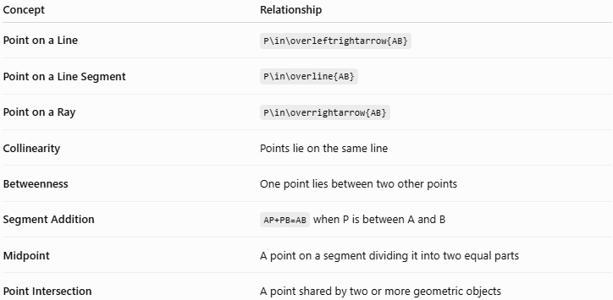
Concept | Relationship
Point on a Line | P\in\overleftrightarrow{AB}
Point on a Line Segment | P\in\overline{AB}
Point on a Ray | P\in\overrightarrow{AB}
Collinearity | Points lie on the same line
Betweenness | One point lies between two other points
Segment Addition | AP+PB=AB when P is between A and B
Midpoint | A point on a segment dividing it into two equal parts
Point Intersection | A point shared by two or more geometric objects

Real-World Applications
# Source: AI Source: Provided by: [Data Path: Persons Table -> ID Column: 1, Name_En Column: Motasem Essam] -> From: [ChatGPT] on [7/25/2026]
Point-on-segment containment is used in:
- Architecture – locating a point along a wall or structural member.
- Engineering – locating components along beams and rods.
- CAD – determining whether a vertex lies on an edge.
- Computer graphics – testing whether a point lies on a rendered edge.
- Surveying – determining whether a measured location lies along a boundary segment.
- Robotics – determining whether a robot position lies along a planned linear path.
- Manufacturing – verifying locations of holes, marks, or features along a component.

Advantages
# Source: AI Source: Provided by: [Data Path: Persons Table -> ID Column: 1, Name_En Column: Motasem Essam] -> From: [ChatGPT] on [7/25/2026]
- Provides an exact definition of a point's position along a finite line.
- Easy to represent using geometric notation.
- Can be tested using coordinates, distances, or vectors.
- Forms the basis for segment division and midpoint concepts.
- Useful in both 2D and 3D geometry.
- Important for computational geometry and CAD.

Limitations
# Source: AI Source: Provided by: [Data Path: Persons Table -> ID Column: 1, Name_En Column: Motasem Essam] -> From: [ChatGPT] on [7/25/2026]
- Coordinate calculations can be affected by numerical precision in computer systems.
- Real-world measurements have tolerances, so exact containment may need a tolerance value.
- Collinearity alone does not prove that a point belongs to the finite segment.
- The endpoint convention must be clear; the standard geometric segment includes both endpoints.

Key Points
# Source: AI Source: Provided by: [Data Path: Persons Table -> ID Column: 1, Name_En Column: Motasem Essam] -> From: [ChatGPT] on [7/25/2026]
- Point on a Line Segment is a type of Point Containment.
- It is represented as:
$$\boxed{P∈\overset{‾}{AB}}$$
- The point must lie between the endpoints or coincide with one of them.
- The endpoints themselves are contained:
$$A,B∈\overset{‾}{AB}$$
- Every point on the segment is also on its supporting line:
$$\boxed{\overset{‾}{AB}⊂\overset{↔}{AB}}$$
- Collinearity is necessary but not sufficient for segment containment.
- If P lies between A and B:
$$\boxed{AP+PB=AB}$$
- Vector representation:
$$\boxed{P=\left(1-t\right)A+tB, 0≤t≤1}$$
- t=0 gives A, t=1 gives B, and 0<t<1 gives an interior point.
- The concept applies in both 2D and 3D geometry.

Conclusion
# Source: AI Source: Provided by: [Data Path: Persons Table -> ID Column: 1, Name_En Column: Motasem Essam] -> From: [ChatGPT] on [7/25/2026]
Point on a Line Segment describes a point that belongs to the finite portion of a line determined by two endpoints. The relationship is expressed as P\in\overline{AB} and requires the point to be collinear with A and B and located between them, including the endpoints. This distinguishes segment containment from simply being on the supporting line. The concept is fundamental to betweenness, segment addition, midpoint, coordinate geometry, and computational geometry.

